

INDUSTRY INTERNSHIP REPORT

Submitted in partial fulfillment of requirement for the award of degree of

Bachelor of Technology

in
Computer Science and Engineering
by
Narendra Kumar

Industry Guide

Mr. Shri Vishnu
at

Bosch Limited

Institute Guide

Mrs. Reena Dewangan

G H Raisoni University, Amravati


2025-26



Declaration

I, hereby declare that the Industry Internship report submitted herein has been carried out by me in BOSCH LIMITED towards partial fulfillment of requirement for the award of Degree of Bachelor of Technology in Computer Science and Engineering. The work is original and has not been submitted earlier as a whole or in part for the award of any degree / diploma at this or any other Institution / University.

I also hereby assign to G H Raisoni University, Amravati all rights under copyright that may exist in and to the above work and any revised or expanded derivatives works based on the work as mentioned. Other work copied from references, manuals etc. are disclaimed.

Name of student | Mobile No | Mail ID  (Other than Raisoni.net) | Signature
Narendra Kumar | 9149217699 | narendra10227908f@gmail.com





Certificate

The Industry Internship Report entitled as VISUAL INSPECTION OF ARMATURE BOLT DEFECTS carried out under our supervision in BOSCH LIMITED by NARENDRA KUMAR for the award of Degree of Bachelor of Technology in Computer Science and Engineering. The work submitted is comprehensive, complete and fit for evaluation.

Mr. Shri Vishnu  Bosch Limited  MIDC Estate Satpur, Trimbak Road, Nashik-422007 | Mrs. Reena Dewangan  Department of Computer Science and Engineering

Dean,
School of Engineering & Technology




PROCEEDINGS OF EXTERNAL VIVA-VOCE EXAMINATION

The viva-voce examination of Mr. NARENDRA KUMAR on this B.Tech dissertation tittle VISUAL INSPECTION OF ARMATURE BOLT DEFECTS was conducted in School of Engineering and Technology in the department of Computer Science and Engineering at G H Raisoni University Amravati on ……………..

During the viva-voce examination following examiners were present.

Guide: Mrs. Reena Dewangan

External Examiner: ___________________________________

Based on the presentation given by the Mr. Narendra kumar both the examiners approves dissertation for the partial fulfillment of the requirements for the degree of Bachelor of Technology in Computer Science and Engineering.

Signature:

Project Guide: ______________________________

External Examiner: __________________________

ACKNOWLEDGEMENT

I would like to acknowledge my deep sense of gratitude to my project guide Mrs. Reena Dewangan, Department of Computer Science and Engineering of G H Raisoni University, Amravati for her constant valuable guidance and encouragement. She gladly accepted all the pains in going through my work again and again and gave me opportunity to learn essential research skills. This Report would not have been possible without her insightful and critical suggestions, her active participation in constructing right models and a very supportive attitude. I will always remain grateful to her for giving direction to my life.

I express my sincere thanks to Honorable Director, Dean-Department of CSE, Internship In charge, Guide for providing the necessary facilities for carrying out the research work.

I would like to acknowledge the support of my parents and my siblings for their continuing support and encouragement.

NARENDRA KUMAR

(Enrollment No. GHRUA22011060407)

CONTENTS

Chapter Illustration | Page No.
List of Tables | i
List of Figures | ii
List of Photographs | iii
Abstract | iv
INTRODUCTION | 01
About Company | 01
1.2 Historical Background | 04
1.3 Location | 05
1.4 Operation Structure | 06
1.5 Vision and Mission of Company | 07
1.6 Product Portfolio | 09
CASE STUDY | 11
2.1 Introduction | 11
2.2 Problem Identification | 13
2.3 Objective | 14
2.4 Work Carried Out about the project /its hardware /  Software of solution implementation | 15
2.4.1 About The Project | 15
2.4.2 Tech Stack Used for Development | 16
2.4.3 Solution Implementation | 19
2.5 Solution Provided | 28
2.6 Results | 30
CONCLUSION | 31
REFERENCES | 32

List of Tables

Table No. | Title | Page No.
1.1 | Company Profile | 3
2.1 | Tech/Stack and Software tools | 18

i
List of Figures

Figure No. | Title | Page No.
1.1 | Company Logo | 1
1.2 | Registered Address | 5
1.3 | Common Rail Injector(CRI)
1.4 | Armature Bolt

ii

List of Photographs

Photograph | Title | Page No.
2.1 | Home Page | 19
2.2 | Login Screen | 20
2.3 | Diary Screen | 22
2.4 | Diary Detail Screen | 23
2.5 | Court Cases Screen | 24
2.6 | Notification Screen | 25
2.7 | Setting Screen | 27

iii
ABSTRACT
In modern manufacturing industries, the reliability, dimensional accuracy, and surface quality of even the smallest mechanical components—such as armature bolts—play a vital role in ensuring the overall safety, efficiency, and long-term durability of larger electromechanical assemblies. Components like these are used in motors, automotive systems, power tools, and various industrial applications. Any defect in an armature bolt, including surface scratches, thread damage, cracks, deformation, or incorrect geometry, can significantly affect the performance of the final product. Traditionally, the inspection of such components has been performed manually by trained operators. However, manual inspection is slow, inconsistent, labor-dependent, and highly prone to human error. These challenges highlight the growing need for automated inspection solutions that can deliver faster, more reliable, and standardized quality checks.
To address these limitations, the present work focuses on designing and developing an automated Visual Inspection System for Armature Bolt Detection, capable of classifying bolts as OK or Not-OK (NOK) based on visible defects. The primary goal of this system is to reduce manual dependency, improve inspection accuracy, and introduce a scalable AI-based methodology that can be adapted to real production environments.
The proposed solution integrates the principles of Machine Vision, OpenCV-based image processing, and ONNX-based Machine Learning inference, all implemented within a Django web framework. The frontend of the system—developed using HTML, CSS, JavaScript, Bootstrap, and Django template rendering—provides a user-friendly interface where operators can upload images of bolts, initiate inspection, visualize classification results, and store relevant configuration details. An SQLite database is used for managing user authentication, and maintaining system settings, ensuring a lightweight yet efficient backend workflow.
In the industrial implementation, the complete system is connected to real-time automation equipment. It communicates with Programmable Logic Controllers (PLCs) using the snap7 library, captures images through a Pylon industrial camera, and executes inspection cycles automatically based on trigger signals from the production line. However, due to organizational confidentiality and restrictions on sharing internal data or code, a simplified prototype version was developed. This prototype preserves the same logical workflow but replaces the real-time camera with a manually uploaded image, making the system easy to demonstrate while maintaining the core inspection capabilities. In this prototype, the Machine Learning model analyzes the uploaded image of the bolt, and classifies it as OK or NOK, enabling quick decision-making regarding whether the component should proceed to assembly or be rejected. It significantly reduces human-induced errors, enhances inspection speed, and promotes standardized quality control practices in industrial settings.
iv

INTRODUCTION
1.1 ABOUT THE COMPANY
Bosch India Limited is one of the most prominent and trusted technology and engineering companies in the country, operating as a subsidiary of Robert Bosch GmbH, a global leader headquartered in Stuttgart, Germany. Established over a century ago, Bosch has grown to become a worldwide symbol of quality, precision, and innovation. In India, the company has played a crucial role in the development of the automotive sector, manufacturing technologies, and industrial automation solutions.

Fig 1.1 Company Logo
Bosch began its operations in India in 1922 and has since expanded into a multi-sector organization with a strong presence in mobility, energy systems, industrial solutions, consumer goods, and smart manufacturing. With multiple production plants, research centers, and development branches spread across the nation, Bosch India is a key contributor to the global Bosch network. The company works extensively in designing, manufacturing, and supplying components that meet international standards of performance and safety.

The Bosch Nashik Plant, established in 1972, stands out as one of the company’s most advanced manufacturing units in India. This facility specializes in the production of Fuel Injection Equipment (FIE) components, precision-machined parts, armature and solenoid components, and other high-accuracy automotive systems. The Nashik plant supports both domestic vehicle manufacturers and global markets through export-oriented production. Equipped with modern CNC lines, automated assembly systems, and high-resolution visual inspection technologies, it plays a strategic role in Bosch’s mobility division.

One of the major strengths of Bosch is its commitment to quality excellence. Every plant, including Nashik, follows strict quality management systems such as ISO standards, lean manufacturing principles, and zero-defect philosophies.The organization invests heavily in innovation to ensure that its products remain reliable, durable, and efficient.

Bosch’s manufacturing approach integrates Industry 4.0 practices, including smart sensors, data analytics, AI-driven visual inspection, and optimized workflows. These technologies enable continuous monitoring, quicker decision-making, and enhanced process transparency across the production line.

Another important element of Bosch’s identity is its emphasis on sustainability and environmental responsibility. The company continuously upgrades its processes to reduce energy consumption, minimize waste, and adopt green manufacturing methods. Bosch Nashik has been recognized for its efforts in renewable energy usage, responsible resource management, and commitment to environmentally friendly operations. Such initiatives align with the company’s global vision of creating technology that benefits both people and the planet.

Bosch India is also known for its strong focus on employee development and workplace culture. The organization provides structured training programs, skill enhancement workshops, and learning opportunities for engineers, technicians, and interns. Safety, professional ethics, teamwork, and continuous learning form the core of Bosch’s work environment. The Nashik plant maintains well-established training centers that prepare employees for modern manufacturing processes, digital tools, and advanced inspection methods.

In addition to manufacturing, Bosch is heavily involved in research and development (R&D). Its R&D centers in India work on mobility solutions, electrification, automation, artificial intelligence, and Internet of Things (IoT) applications. These technological developments support Bosch plants worldwide, enabling India to become an important contributor to global engineering projects.

Through its commitment to innovation, quality, sustainability, and customer satisfaction, Bosch India continues to strengthen its position as a leader in engineering and manufacturing excellence. The Nashik plant reflects these values through its high-precision production lines, rigorous quality control systems, and dedication to continuous improvement. As part of the global Bosch family, the plant plays a pivotal role in delivering world-class automotive components that meet the stringent demands of both national and international markets.

Table 1.1 Company Profile
Name of Company | Bosch Limited
Address of the Company | MIDC Estate Satpur, Trimbak Road, Nashik-422007
Name of CEO | Guruprasad Mudlapur
Name Of HR | Remya Nair
Established Year | 1972-Nashik Plant
Major Products / Services | Fuel Injection Systems, Diesel injector nozzles
Vision of the Company | To be a global leader in technology, mobility, and automation
Global Presence | 60+ countries worldwide

1.2 HISTORICAL BACKGROUND
Established in 1972, the Bosch Nashik Plant has emerged as a cornerstone of Bosch India’s manufacturing capabilities, reflecting the evolution of both the company and the Indian automotive industry. Over the decades, the plant has continually adapted to meet the growing demands of the market, delivering high-quality automotive components that power vehicles across the country and beyond.
From its early focus on Diesel Fuel Injection Equipment (FIE) components for commercial vehicles and agricultural machinery, the Nashik plant has expanded its portfolio to include armature components, solenoid parts, injectors, precision-machined components, and other critical automotive parts. This diversification enables the plant to serve a broad spectrum of vehicle categories, ranging from two-wheelers and passenger cars to heavy-duty trucks and industrial engines.
Guided by a commitment to technological advancement, Bosch Nashik has embraced continuous modernization. Beginning with conventional machining systems, the plant progressed to CNC machining centers, automated assembly lines, high-precision grinding technologies, and advanced digital quality control systems. Adopting lean manufacturing principles, zero-defect quality, and continuous improvement, the plant has consistently achieved high standards of productivity and operational excellence.
Key Areas of Expertise:
Precision Manufacturing: The plant delivers high-accuracy automotive components, leveraging advanced machining, assembly, and inspection technologies.
Smart Manufacturing & Industry 4.0: With AI-based visual inspection, real-time monitoring, and digital dashboards, Bosch Nashik integrates cutting-edge technologies to enhance efficiency and quality.
Sustainable Operations: Committed to environmental responsibility, the plant implements renewable energy, waste reduction, and green manufacturing initiatives, earning multiple awards and certifications in quality, safety, and sustainability.
Today, the Bosch Nashik Plant stands as one of Bosch’s most important manufacturing hubs in India. Its skilled workforce, continuous modernization, and strong quality culture make it a vital contributor to Bosch’s global supply chain. By embracing emerging technologies, expanding product offerings, and supporting next-generation mobility solutions, the Nashik plant continues to drive innovation, reliability, and excellence in the automotive industry.

1.3 LOCATION
The Bosch Nashik Plant is located at 75, MIDC Estate, Satpur, Trimbak Road, Nashik – 422007, Maharashtra, India.
Strategically situated in Nashik’s industrial region, this location offers excellent connectivity via highways, rail networks, and proximity to major supply‑chain routes. It enables smooth transport of raw materials and finished products, supporting both domestic distribution and Bosch’s global export operations.
Nashik’s strong industrial ecosystem, skilled local workforce, and supportive regional infrastructure make this plant an ideal hub for high‑precision automotive component manufacturing. The site’s positioning near key automotive suppliers and markets helps ensure efficient operations, shorter lead times, and effective supply‑chain coordination.

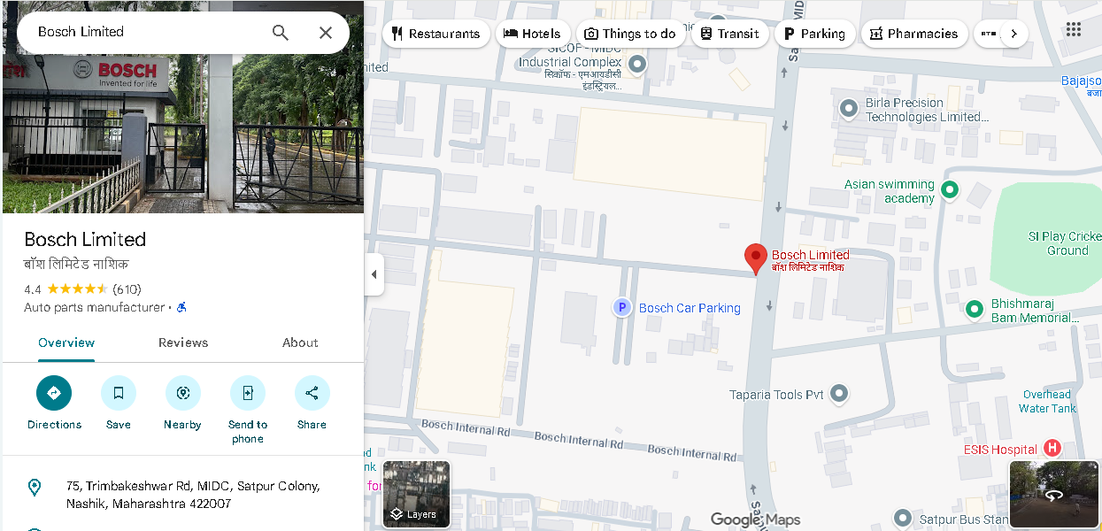
Fig 1.2 Registered Address
1.4 OPERATIONAL STRUCTURE
Bosch Limited Operational Structure
The Bosch Nashik Plant operates through six key departments, each playing a critical role in ensuring efficient, high-quality automotive component manufacturing:
1. QMM (Quality Management & Monitoring):
- Ensures zero-defect quality standards across all processes.
- Conducts inspections, audits, and do quality checks
2. MFC (Manufacturing Childs Components):
- Handles machining, automated assembly, and high-precision grinding.
- Produces components with tight tolerances and global standards.
3. MFN (Manufacturing Nozzels):
- Responsible for precision machining and finishing of diesel injector nozzles.
- Performs critical operations such as grinding, lapping, and fine polishing of nozzle components.
4. TEF (Technical Functionality):
- Maintaining technical functions, smart manufacturing, and Industry 4.0 practices.
- Performs preventive and predictive maintenance of machines, tools, and production equipment.
5. Logistics:
- Manages inbound materials, internal supply movement, and outbound shipments.
- Ensures timely delivery to customers and other Bosch facilities.
6. HR (Human Resources):
- Oversees workforce management, training, and employee welfare.
- Ensures skill development and adherence to safety and compliance standards.
This departmental structure enables Bosch Nashik to maintain operational efficiency, high productivity, and global-quality standards while supporting innovation and sustainable manufacturing.

1.5 VISION & MISSION OF COMPANY
Vision – Revolutionizing Connections and Growth in the Digital Era
The vision of Bosch, including the Bosch Nashik Plant, is to deliver innovative, high-quality, and sustainable mobility solutions that contribute to safer, cleaner, and more efficient transportation worldwide. Bosch aims to be a global leader in mobility technologies by combining precision manufacturing with digitalization, environmental responsibility, and long-term value creation.
At the Nashik Plant, this vision translates into consistently producing fuel-injection components that meet worldwide standards and supporting the global automotive industry with reliable products. The plant envisions maintaining its leadership in precision engineering, advanced manufacturing, and continuous improvement practices. Through its commitment to excellence, Bosch Nashik strives to contribute directly to Bosch’s international vision of shaping the future of mobility with technologies that are safe, efficient, and environmentally conscious.
The plant also aligns with Bosch’s long-term goal of integrating Industry 4.0, automation, and AI-based systems across operations, ensuring high accuracy, higher productivity, and minimal environmental impact. Bosch’s vision strongly emphasizes sustainability, customer satisfaction, employee growth, and responsible resource management, ensuring that the Nashik facility contributes to a cleaner and more sustainable future. The role of IT in shaping the modern business landscape is central to this vision—enabling organizations to move forward with confidence, clarity, and purpose.
Additionally, the vision highlights the importance of technological leadership, global competitiveness, and continuous innovation. Bosch Nashik aims to remain a benchmark plant within Bosch worldwide by adopting smart technologies, enhancing process capability, and promoting a culture of operational excellence. The plant also focuses on future-ready manufacturing that adapts to emerging mobility trends, ensuring it continues to deliver value to customers, society, and the global automotive ecosystem.

MISSION OF COMPANY
The mission of Bosch Nashik Plant is to manufacture world-class automotive components—primarily injectors and nozzles—with a strong emphasis on precision, quality, and technological excellence. The plant follows Bosch’s global mission, which focuses on operational excellence, customer value, and sustainable growth.
1. Commitment to High-Quality Manufacturing
The Nashik Plant’s mission is to consistently produce components that meet strict international standards. Bosch emphasizes zero-defect quality, supported by advanced quality management practices, automated inspection systems, and continuous process monitoring. The plant ensures that every product delivered aligns with the expectations of major global automotive manufacturers.
2. Operational Excellence Through Advanced Technologies
A core mission of the plant is to adopt and implement the latest technologies, including automation, CNC machining, high-precision grinding, digital production monitoring, and AI-based inspection systems. Bosch Nashik focuses on maintaining high efficiency, reducing process variations, and strengthening manufacturing reliability.
The integration of Industry 4.0 tools—such as predictive maintenance, digital dashboards, and interconnected machines—supports Bosch’s mission to build smart factories that can adapt to future technological needs.
3. Sustainability and Environmental Responsibility
Bosch Nashik follows Bosch Group’s global mission of reducing environmental impact, increasing energy efficiency, and promoting sustainable operations. The plant is committed to reducing waste, optimizing resource usage, and supporting cleaner production processes. Bosch’s overall goal of achieving carbon-neutral operations globally is reflected in Nashik through initiatives like energy-efficient equipment, waste-reduction drives, and environmentally friendly manufacturing processes.
4. Customer Satisfaction and Global Supply Support
A major mission of the plant is to ensure timely delivery, strong supply-chain coordination, and dependable service for automotive customers worldwide. Bosch Nashik supplies components not only to domestic OEMs but also to Bosch facilities across the globe. The plant aims to consistently provide value through quality products, on-time delivery, and transparent communication.

5. Employee Development and Safety Culture
Bosch emphasizes the growth of its employees, and the Nashik Plant’s mission includes creating a safe, inclusive, and skill-oriented work environment. The plant invests in continuous training programs, technical skill upgrades, safety awareness initiatives, and career-development systems.
The mission is to cultivate a workforce that is capable, motivated, and aligned with Bosch’s culture of innovation, responsibility, and operational discipline.
6. Continuous Improvement and Innovation
Bosch Nashik operates with a strong mission toward continuous improvement. Using Kaizen, Lean practices, and standardized operating procedures, the plant aims to improve productivity, reduce downtime, enhance workflow efficiency, and strengthen product reliability. Innovation is encouraged at every level—from machine operation to engineering and process optimization.
1.6 PRODUCT MANUFACTURED
1.6.1 Common Rail Injectors (CRI)
- Advanced fuel-injection units for modern diesel engines.
- Manufactured with high-pressure precision mechanisms to deliver fuel at optimal pressure and timing.
- Designed to support BS6 / Euro-6 compliant engines, delivering cleaner combustion, better fuel efficiency, and lower emissions.
- Developed using state-of-the-art manufacturing processes, quality control and calibration to meet global automotive standards.
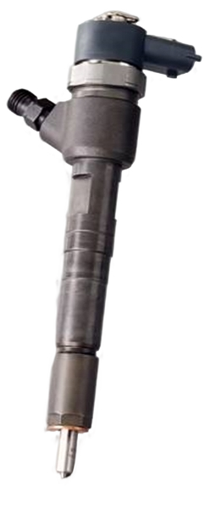
Fig 1.3 Common Rail Injector (CRI)
1.6.2 Diesel Injector Nozzles
- High-precision nozzles that control fuel spray into the combustion chamber.
- Manufactured through processes like precision drilling, lapping, polishing, and calibration to ensure accurate flow rate and spray pattern.
- Critical for engine performance: good nozzles lead to efficient combustion, better power output, reduced smoke and emissions, and improved longevity of engines.

1.6.3 Nozzle Holder Assemblies (NHA) & Injector Component Assemblies
- Assemblies that combine injectors, nozzles and internal components to create fully functional injector units.
- Includes precision-engineered internal parts such as needle assemblies, control valves, spacers, and seals — all manufactured under strict tolerances.
- Components undergo rigorous testing (pressure testing, leakage check, flow calibration) to ensure reliability and durability under high-pressure and high-temperature conditions.
1.6.4 Emission-Compliant and Export-Grade Components
- Components designed to meet stringent emission norms (BS6 / Euro-6) — ensuring compatibility with modern engines and environmental standards.
- Manufactured with high precision, durability, and quality control making them suitable for international markets as export-grade parts.
1.6.5 Quality, Precision & Manufacturing Excellence
- All products are manufactured under strict quality management systems (with precision inspections and calibrations).
- Use of advanced manufacturing methods, automation, and continuous improvement practices to ensure consistency and reliability.
- The output from Bosch Nashik contributes significantly to both domestic automotive sector and global supply chain, supplying to OEMs and export markets worldwide.

CASE STUDY
2.1 INTRODUCTION
Visual inspection plays a crucial role in modern manufacturing, particularly in the production of components where even minor defects can result in significant performance issues or complete failure of the final assembly. Armature bolts fall into this category—they are small but highly important elements used across automotive and electromechanical systems. Because of their functional significance, even slight imperfections such as cracks, deformations, incorrect groove patterns, surface anomalies, or improper threading can lead to incorrect assembly, reduced operational lifespan, or malfunctioning of the final product.
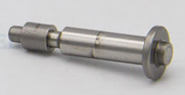
Fig 2.1 Armature Bolt
Traditionally, the inspection of armature bolts has been carried out manually by trained operators. Although this approach is workable for low-volume production, it becomes increasingly inefficient as manufacturing scales up. Modern production environments demand high throughput, uniform quality, and reliable accuracy, which manual inspection struggles to consistently deliver. Human-related factors—such as fatigue, differences in skill level, inconsistent interpretation of defects, and varying lighting conditions—further contribute to inaccuracies and missed defects.
To address these challenges, industries are progressively adopting advanced machine vision systems that automate the entire inspection workflow with far greater accuracy and reliability than traditional manual methods. In a modern automated inspection setup, high-resolution industrial cameras capture detailed images of each component as it moves along the production line. These images are then processed using sophisticated image-processing pipelines built with technologies such as OpenCV, where operations like noise removal, contrast enhancement, edge detection, and feature extraction help reveal critical visual details.
Once preprocessed, the images are analyzed using machine learning and deep learning models that have been trained on thousands of sample images. These models learn to recognize patterns, surface defects, dimensional inconsistencies, and other anomalies that may not be easily detectable by the human eye. Based on this learned intelligence, the system classifies each part as OK (acceptable) or NOK (defective) with high precision.
By integrating machine vision into the inspection process, industries achieve faster cycle times, improved repeatability, and near-zero human error. Automated inspection ensures that every component is evaluated consistently under the same conditions, eliminating subjectivity and fatigue associated with manual inspection. Furthermore, these systems enhance overall productivity, reduce operational costs, and allow human operators to focus on higher-value tasks rather than repetitive visual checking.
The organization’s existing inspection setup includes PLCs (Programmable Logic Controllers), Basler industrial cameras integrated through the Pylon SDK, ONNX-based machine learning models, and Python-powered OpenCV image processing.
The combined system performs real-time defect detection and communicates inspection results to PLCs using the snap7 library, enabling immediate decision-making and automated control actions based on the detected outcomes.
However, due to strict data security and intellectual property restrictions, the full production-level codebase and models cannot be taken outside the organization. To overcome this limitation, a separate prototype was created independently, designed to replicate the same core inspection pipeline. Instead of real-time camera feeds or PLC communication, the prototype allows users to manually upload images while keeping the image processing and ONNX inference workflow identical to the original system.
This case study provides an overview of the inspection problem, the need for automation, and the technologies utilized. It also outlines the implementation of the prototype built using Django, OpenCV, and ONNX Runtime, demonstrating how modern machine vision techniques can be applied effectively for automated defect detection in armature bolt inspection.

2.2 PROBLEM IDENTIFICATION
Industries face several operational challenges when inspecting armature bolts manually. These challenges not only affect the quality of the final product but also have a direct impact on production efficiency, reliability, and long-term maintenance costs. A detailed explanation of these issues is provided below:
- Inconsistency in Inspection Results - Manual inspection depends heavily on human judgment, which naturally varies from one operator to another. Factors such as fatigue, eye strain, and environmental conditions can lead to inconsistent decisions, where the same bolt may be marked as acceptable by one operator and defective by another. This lack of standardization reduces the overall reliability of the inspection process.

- High Inspection Time - Since every bolt must be visually checked, manual inspection significantly slows down the production flow. As production volume increases, the inspection process becomes a bottleneck, affecting delivery timelines and overall manufacturing throughput.

- Limited Defect Detection Capability - Human eyes are not always capable of detecting very small defects. Minor cracks, surface scratches, improper groove patterns, and slight dimensional deviations are often overlooked during manual checks. Such undetected defects can compromise assembly quality or lead to premature failure during product operation.

- High Defect Escape Rate - Because of the above limitations, defective bolts frequently pass through inspection unnoticed. These escaped defects travel further down the production line, resulting in malfunctioning assemblies, increased rework, customer complaints, and financial loss for the manufacturer.

- Lack of Traceability - Manual inspection typically does not maintain systematic records of defects, images, inspection decisions, or batch-wise performance data. Without traceability, it becomes difficult to analyze trends, identify recurring defects, or perform root-cause analysis. This limits an organization’s ability to improve long-term quality control processes.

- No Real-Time Automation - Manual inspection systems cannot integrate with PLCs or automated machinery. As a result, they cannot support real-time sorting or automatic rejection of defective bolts. This prevents industries from achieving a fully automated workflow, which is essential for modern high-speed manufacturing systems.
2.3 OBJECTIVE
The main objective of this project is to develop a reliable, automated visual inspection system capable of identifying defects in armature bolts with high accuracy. Since manual inspection often leads to inconsistency, fatigue-related errors, and longer inspection times, this project aims to replace traditional methods with an AI-driven machine vision approach. The following objectives have been defined to ensure that the prototype as well as the industry-scale system are clear, structured, and technically aligned.
Primary Objectives
- To design a machine vision system capable of detecting armature bolt defects - The goal is to develop an AI-based inspection mechanism that can analyze bolt images and recognize various types of defects such as cracks, bends, deformations, and improper surface finish. This ensures uniform and precise defect identification.
- To classify each bolt as OK or NOK using AI/ML models - A trained machine learning model will be used to differentiate acceptable bolts from defective ones, ensuring a standardized decision-making process that reduces human error.
- To automate the inspection cycle for fast and accurate decision-making - By minimizing manual intervention, the system aims to significantly reduce inspection time while increasing quality consistency across all units.
Prototype-Specific Objectives
- To develop a Django-based frontend for uploading images and viewing inspection results - The prototype’s user interface will allow users to manually upload bolt images, trigger the inspection process, and view results such as OK/NOK classification in a simple dashboard.
- To use OpenCV and ONNX Runtime to process bolt images and generate predictions - Since real industrial camera access is restricted, the prototype will rely on offline images and an exported ONNX model for inference, ensuring that the workflow remains similar to the actual system.
- To replicate the industry workflow without PLC or camera dependencies - The prototype aims to simulate the complete inspection process—image input, processing, classification, and result display—without requiring actual PLC communication or camera hardware.
- To store configuration settings and admin details using SQLite - Basic application settings, admin login details, and any configurable parameters will be saved in SQLite, mirroring the structured data storage used in real industrial setups.

Industry Integration Objectives (Original System)
- Interface with PLCs using the snap7 library - In the full industrial setup, PLC communication is essential for triggering hardware functions and sending inspection decisions back to the assembly line.
- Capture real-time bolt images using Basler Pylon cameras - The original system uses industrial-grade cameras to continuously capture high-resolution images of bolts for real-time inspection.
- Automate NOK/OK sorting based on PLC triggers - Once the ML model predicts the bolt condition, the PLC executes actuator-based sorting to physically separate defective pieces from good ones.
- Log results for traceability and quality analysis - A complete record of inspected bolts, timestamps, and classification results ensures production transparency, fault diagnosis, and long-term quality improvement.

2.4 WORK CARRIED OUT
2.4.1 About the Project
The project focuses on designing and developing an automated visual inspection system for detecting defects in armature bolts using machine learning and computer vision techniques. Armature bolts are critical components used in a variety of electromechanical assemblies, which means any defect in their shape, structure, or surface condition can directly impact the performance and reliability of the final product. Traditionally, bolt inspection is carried out manually, where operators visually check each bolt and categorize it as either acceptable (OK) or defective (NOK). However, this manual process is slow, inconsistent, and prone to human errors. Therefore, this project aims to create a prototype system that mimics the industrial inspection workflow using a combination of image processing, machine learning, and a Django-based web frontend.
The project is divided into three major components: Image Acquisition, Image Processing and ML Inference, and Frontend & Control System. Each component plays a crucial role in ensuring the system is functional, consistent, accurate, and capable of replicating real-time industrial inspection logic.
1. Image Acquisition
Image acquisition forms the foundation of any computer vision system because the quality of the input directly affects the accuracy of the inspection results. In an industrial environment, the organization uses Basler industrial cameras connected through the Pylon SDK to capture high-resolution images of bolts in real time. These cameras are integrated into the production line and triggered by PLC signals, ensuring that every bolt passing through the station is captured from the correct angle under controlled lighting conditions. This setup helps the machine learning model receive consistent input images, which increases accuracy.
However, for the purpose of this prototype, direct access to industrial cameras and PLC connectivity is not possible. Therefore, the project uses a modified workflow where images are uploaded manually through the Django frontend. This still allows the envisioned ML pipeline to function exactly as intended, while avoiding any dependencies on hardware that cannot be accessed outside the organization. Users can upload images from a pre-collected set containing examples of both OK and NOK bolts. This approach retains the logic of the real system while remaining lightweight and easy to demonstrate.

2. Image Processing & Machine Learning Inference
The core intelligence of the inspection system lies in the machine learning model and the preprocessing pipeline. Before the model can classify an image, the system performs several essential preprocessing steps using OpenCV, such as:
- Converting the image to grayscale
- Resizing to a standard input dimension
- Normalizing pixel intensity
- Applying thresholding or denoising filters
- Enhancing bolt edges or contours for better feature extraction
These steps help reduce noise and improve the model’s ability to understand the structural pattern of the bolt.
Once preprocessing is complete, the bolt image is passed to the machine learning model exported in ONNX format. In the industry setup, the ONNX model is usually trained using large datasets captured from the Basler camera. The model learns to identify subtle differences between defective and non-defective bolts, making it capable of detecting cracks, deformations, missing sections, improper grooves, and other defects.
In this prototype, the same process is replicated using a lightweight ONNX model that runs through the ONNX Runtime, ensuring fast and efficient inference without requiring GPU resources. The model outputs whether the bolt is:
- OK – suitable for further assembly
- NOK – defective and should be rejected
This result is then displayed on the user interface through the Django frontend.
3. Frontend & Control System
The final major component of the system is the Django-based frontend and backend, which serves as the user interface and central logic controller. The frontend has been designed to resemble the industrial system as closely as possible while remaining simple and user-friendly. It allows users to:
- Upload images of bolts for inspection
- Trigger machine learning inference
- View OK/NOK classification results
- Access an administration panel
- Configure PLC settings (in the actual system)
The interface is built using HTML, CSS, JavaScript, Django, Bootstrap, ensuring a responsive layout that works on various screen sizes. Although the prototype does not communicate with an actual PLC, the system maintains the structure for PLC configuration using Django models. This makes it easier to integrate real PLC communication in the future using libraries like snap7.
All important data such as configuration settings, user login details, and inspection metadata are stored in SQLite, providing a simple and lightweight storage solution for the prototype. In the industrial version, this database layer would connect to more robust systems and include detailed logging and traceability features.
2.4.2 Tech / Stack Software Tools
The development of the visual inspection prototype relies on a carefully selected technology stack that ensures efficiency, maintainability, and scalability. The system is divided across four major areas—Frontend, Backend, Machine Vision, and Machine Learning—along with an additional layer of industrial hardware components used only in the organization’s real-time production system. While the prototype focuses on software-driven inspection using uploaded images, the technology stack remains closely aligned with the industrial setup to allow seamless future integration.
Frontend Technologies The frontend forms the user interface of the application, allowing users to upload images, interact with the system, and view inspection results. The following technologies are used.
HTML5 It is used to create the structural layout of the web pages. It defines the components such as input forms, buttons, image preview areas, and display sections for showing OK/NOK classifications. HTML5 provides a clean and stable base for building a professional and responsive user interface.
CSS3 It is used for styling the frontend, ensuring proper alignment, spacing, color schemes, and overall visual appeal. It helps maintain a consistent design throughout the interface and enhances readability and user experience.
JavaScript It adds interactivity to the frontend. It helps manage dynamic elements such as previewing uploaded images, showing processing indicators, and handling frontend validations before a request is sent to the backend.
Bootstrap further enhances the interface with pre-built components such as grids, buttons, cards, and responsive layouts. It ensures that the system is compatible with various screen sizes, which is important for operators who may access the interface from different devices or resolutions.

Django Templates engine is used to dynamically render HTML pages. It allows backend values—such as inspection results or error messages—to be displayed directly on the frontend. This creates a smooth connection between user inputs and system outputs.
Backend Technologies
The backend handles the core functionality of the system, including processing requests, running the machine learning inference, and storing essential application data.

Django
Django is a high-level Python web framework used to structure the backend. It manages URL routing, form handling, API endpoints, user authentication, and integration with the machine learning model. Django’s MVC architecture ensures clean separation between logic and presentation.

SQLite Database
SQLite is used for storing configuration data, admin login credentials, and any required system settings. It is lightweight, fast, and sufficient for prototype-level development while providing a structure similar to larger databases used in industrial environments.

3. Machine Vision Technologies
Machine vision capabilities are essential for preprocessing bolt images before they are passed to the ML model. These libraries help ensure that the images are standardized and ready for analysis.

OpenCV
OpenCV is the main library used for image processing. It handles tasks such as resizing, grayscale conversion, thresholding, noise reduction, and other enhancements required to prepare the bolt images for the model. It ensures consistency across all uploaded images.

NumPy
NumPy supports numerical operations required during preprocessing. It is essential for array manipulation and feeding pixel data into the ONNX model.

PIL (Python Imaging Library)
PIL is used for image loading, format conversion, and basic transformations. It supports compatibility between uploaded images and the internal processing pipeline.

4. Machine Learning Technologies
Machine learning forms the intelligence layer of the system, responsible for classifying each bolt as OK or NOK.

ONNX Model
The machine learning model is exported in ONNX format, which makes it portable, lightweight, and framework-agnostic. It ensures that the same model used in training can be deployed efficiently in both prototype and industrial setups.

ONNX Runtime (ort)
ONNX Runtime executes the ONNX model efficiently, providing fast inference speed even without GPU support. It ensures low latency during prediction, which is important for real-time industrial inspection.

Custom Python classificationModel
This component acts as the wrapper around the inference pipeline. It handles loading the ONNX file, preprocessing inputs, running predictions, and returning OK/NOK results to the Django backend.

5. Industrial Hardware Components (Used in the Full Company System)
These components are used only in the real-time industrial version and are not required in the prototype, but understanding them is important for demonstrating knowledge of the complete system.

snap7
This Python library manages communication with Siemens PLCs. It allows reading and writing data blocks, enabling real-time integration with sorting mechanisms and machinery.

Pylon (Basler Camera SDK)
Pylon is essential for capturing high-resolution images from Basler industrial cameras. It provides precise camera control, including exposure, focus, and triggering settings.

PLCManager Module
This is a custom module used in the company to handle PLC workflows, trigger events, and manage communication between machine vision output and the physical sorting system.

2.4.3 Solution Implementation
The implementation of the Visual Inspection System for Armature Bolt Inspection was carried out using a modular, scalable, and production-oriented architecture. The goal was to recreate a functional prototype based on the technologies and workflow used in the organisation, while adapting it to a standalone environment where images are manually uploaded instead of captured through an industrial camera or processed via PLC-driven automation. The solution integrates machine learning–based classification, image preprocessing, backend logic, and a Django-based web interface to deliver a smooth and user-friendly inspection flow.
The following sections describe the entire implementation in a structured and comprehensive manner.

System Architecture Overview
The system follows a multi-layered architecture to ensure separation of concerns, maintainability, and scalability. The architecture consists of four major blocks: configuration management, device management modules, image processing and inference modules, and the Django-based frontend–backend framework.
The device management block includes modules such as the Camera Manager and PLC Manager. These modules replicate the industrial logic used in real-time production environments. The Camera Manager is responsible for handling image acquisition procedures, while the PLC Manager simulates shop-floor hardware communication. Even though the prototype does not use PLC signals or industrial cameras, the architecture retains these modules to reflect the actual organisational structure.
The image processing block includes the preprocessing pipeline, ONNX inference module, and the inference handler. These modules prepare the uploaded images, run the trained ONNX model, and evaluate whether the bolt qualifies as OK or NOK.
The frontend and backend block includes Django views, models, templates, and static resources such as HTML, CSS, JavaScript, and Bootstrap. This section ensures smooth communication between the user interface and the inspection logic.
Overall, this architecture ensures modularity, enabling each component to be updated independently while maintaining a unified workflow
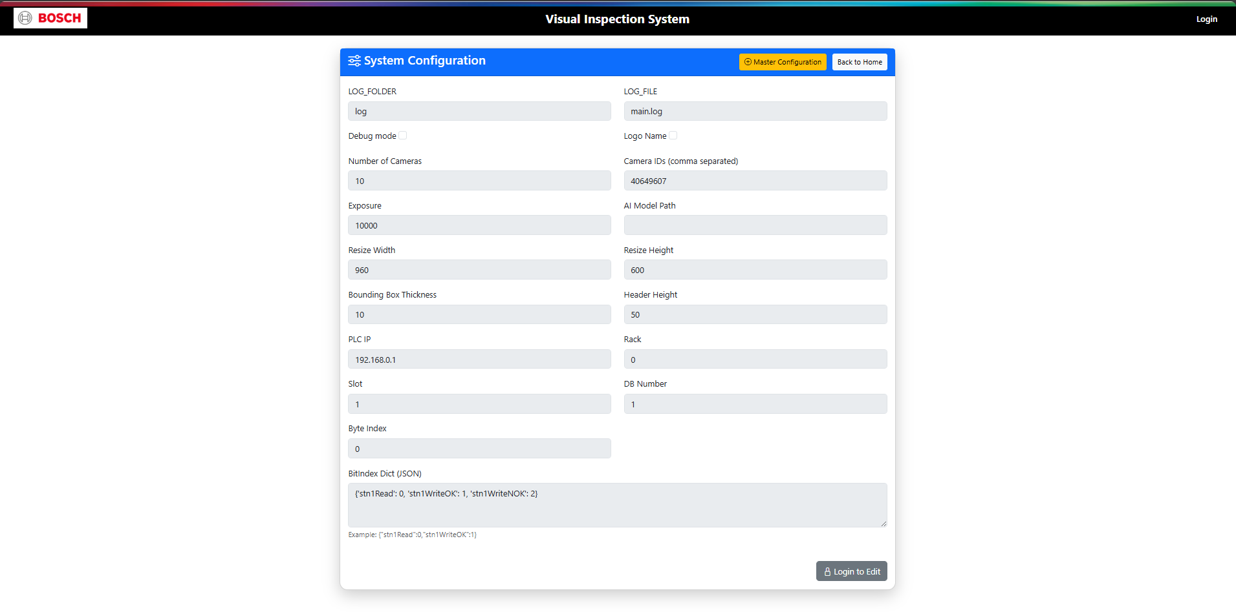
2.1 System Configuration

Configuration and Initialization
The system uses a central configuration module that stores global parameters required across the entire application. In the organisational project, configuration files were used extensively for storing model paths, camera settings, PLC addresses, and image directories. For the prototype, the configuration file retains all relevant parameters required by the image processing and inference modules.
During system initialization, configuration values are imported and used to create model inference sessions, define directory structures, and prepare any required objects. The ONNX runtime session is initialized at application startup to avoid repeated overhead. Image directories are validated to ensure file availability and proper pipeline execution.
The structured use of configuration files ensures consistency, reduces hard-coding, and simplifies future updates. It also mirrors the organisation’s real-time system, enabling your prototype to reflect industrial-grade design practices.

Camera Manager Module
In industrial settings, the Camera Manager handles image acquisition directly from Basler cameras using PyPylon. It also applies real-time settings like shutter speed, exposure, gain, and acquisition triggers. The organisation’s code includes imports such as:

- from pypylon import pylon
- from PIL import Image
- and multiple image processing utilities
However, since external hardware cannot be used in your prototype, the Camera Manager is redesigned to simulate image acquisition by handling uploaded images. Instead of capturing images from the camera, the module ensures that uploaded images follow the standard naming, resolution, and format compatibility used in the production pipeline.
This alignment ensures that your prototype remains structurally consistent with the actual organisational workflow while functioning independently. The Camera Manager plays the role of receiving and validating images before sending them for preprocessing.

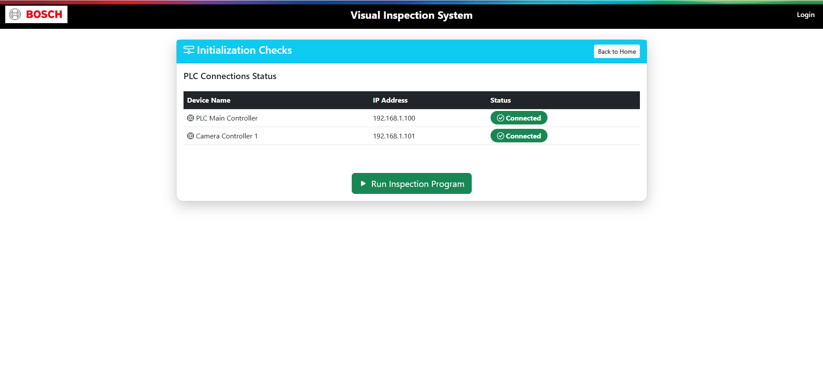
2.2 Initializaion Checks

PLC Manager Module
The organisational project uses Siemens S7 PLCs to determine inspection triggers, conveyor movements, sensor states, and classification output actions. The system imports PLC libraries such as:
- import snap7
- from snap7.util import get_bool
- from snap7.types import Areas, S7WLBIt
In your prototype, PLC communication is not required. However, the PLC Manager module is retained in a simplified form to maintain architectural similarity. Instead of processing real PLC signals, it performs simulated trigger checks and status updates. This ensures consistency when explaining system design in your report, since the PLC logic remains aligned with organisational principles while functioning independently for demonstration.
The PLC Manager structure in the prototype becomes a placeholder that helps maintain the integrity of the modular industrial design.

Image Preprocessing Pipeline
The preprocessing module is responsible for preparing each uploaded image before feeding it into the ONNX model. This pipeline mirrors the steps used in the organisation’s system and includes:
- Image loading using OpenCV or PIL
- Conversion to the required color format
- Resizing to the model’s expected input shape
- Normalization of pixel values
- Reshaping into batches suitable for inference
- Optional noise reduction and quality checks
The organisational code uses libraries like OpenCV (cv2), NumPy (numpy), and sometimes Matplotlib for visualization. Your prototype uses the same structure, ensuring that the uploaded images follow the same transformation sequence that the real-time industrial model expects.
This pipeline removes irregularities between different images, increases model reliability, and ensures consistent classification performance.

ONNX Runtime Inference Module
The ONNX Runtime module forms the core of the bolt inspection system. It loads the pre-trained machine learning model in .onnx format and performs inference on the preprocessed images. The organisational system uses:
- import onnx
- import onnxruntime as ort
The prototype uses the same libraries to maintain structural accuracy. The inference module loads the model once during initialization for efficiency. When an image is processed, the module converts it into the required tensor format, runs inference using the ONNX session, and retrieves the output class along with a confidence score.
These outputs are further used by the inference handler to determine whether the bolt is OK or NOK. The modular design ensures that the ONNX engine can be replaced with future updated models without changing the rest of the pipeline
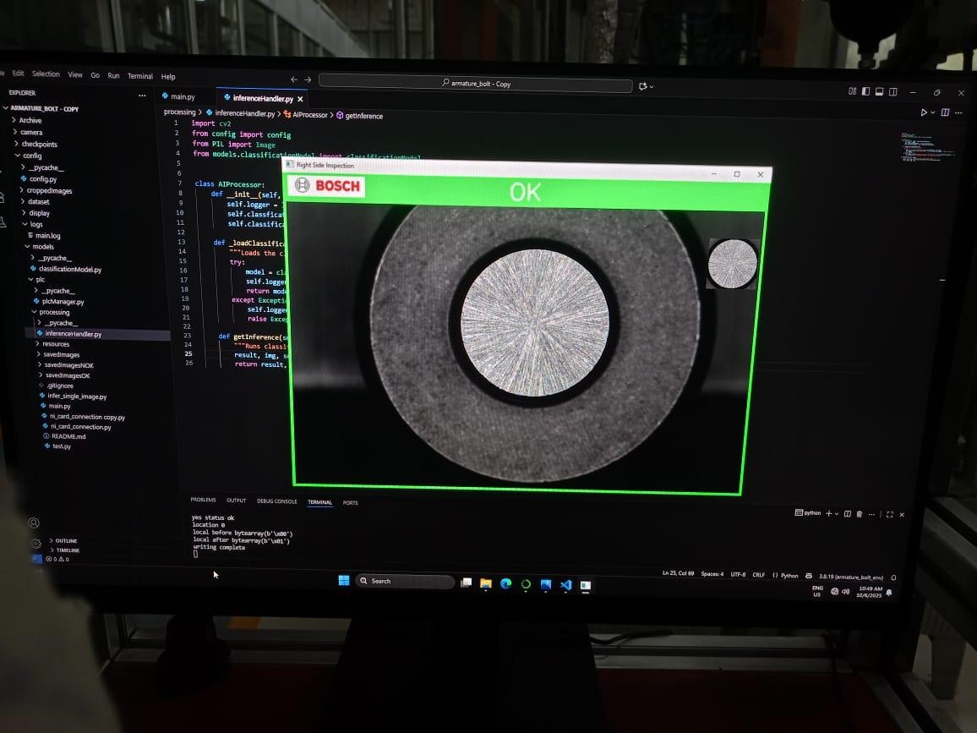
2.3 OK Part
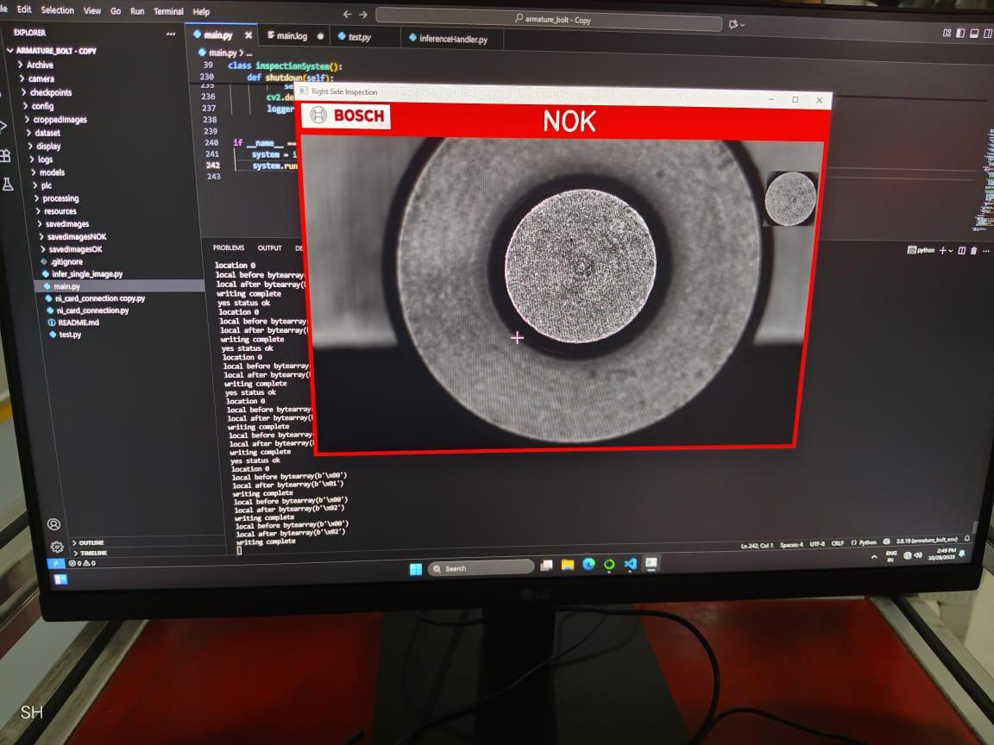
2.4 NOK part

Inference Handler Logic
The inference handler acts as the decision-making unit. It receives confidence scores, class indices, and output probabilities from the ONNX inference module. Based on predefined threshold values, it decides whether the inspected bolt meets quality standards.
The organisational project uses a similar handler to manage predictions and trigger PLC actions. In your prototype, the handler:

- Evaluates model output
- Applies logical rules for OK/NOK classification
- Records results and timestamps
- Prepares the final response for the Django frontend
This module ensures that all inspection outputs remain consistent and reliable.

Display / Visualizer Module
In industrial settings, the visualizer displays real-time inspection results on an operator screen. The organisation uses Matplotlib, OpenCV visualization windows, and custom dashboards.
In the prototype, this module is adapted to work through the Django frontend. Instead of using Matplotlib pop-ups, results are sent to HTML templates for display. Image previews, classification results, and confidence percentages are shown directly on the user interface, ensuring clarity and simplicity.
The visualizer enhances the usability of the system and helps the operator understand each inspection result without requiring technical interpretation.

Logging and Archiving Module
The logging module records image names, timestamps, classification results, and confidence values. This data is stored in SQLite using Django’s model system. The organisational setup uses Python’s logging library along with file-based logs. The prototype uses:

- Django database logging (SQLite)
- Python’s logging module for backend events
- Dedicated folders for storing uploaded images
This ensures that every inspection event is traceable and can be used for audits or performance evaluations.

Frontend & Django Integration
The Django-based frontend completes the system by providing a user interface where images can be uploaded, processed, and reviewed. The frontend is built using:
- HTML for structure
- CSS for styling
- JavaScript for interactivity
- Bootstrap for responsive design
- Django Templates for dynamic data rendering
Uploaded images are passed to Django views, which then trigger preprocessing and inference. The results are displayed on a clean interface that shows:
- Image preview
- OK/NOK status
- Confidence score
- Inspection history
SQLite serves as the database backend, storing logs and image references. The integration between Django and the ML pipeline ensures that the prototype accurately simulates a real-world inspection environment.0

Complete Workflow
The overall workflow of the system is as follows:
- User uploads an image through Django interface
- Image is saved in media directory
- Preprocessing module prepares the image
- ONNX Runtime performs inference
- Inference handler applies logic for OK/NOK
- Result is stored in SQLite
- Frontend displays classification and preview
- Logs are accessible via Django admin

System Scalability
The system is designed with scalability in mind. Its modular architecture enables the prototype to be extended to a real-time environment by reconnecting PLC modules, industrial cameras, conveyor triggers, and automation hardware. New datasets and updated ONNX models can be integrated without modifying the system structure.
This design ensures long-term usability and adaptability.

2.5 SOLUTION PROVIDED
The solution developed for this project provides a complete end-to-end visual inspection workflow that replicates the essential functions of an industrial bolt-inspection system. Although the full production system used by the organization includes PLC integration, industrial cameras, and dedicated automation hardware, the prototype created in this project successfully demonstrates the same inspection logic, data flow, and functional behaviour using software-based components. The primary objective of the solution is to identify whether an armature bolt is OK or NOK based on visual characteristics captured in an image.
The following subsections describe the complete solution provided.
Web-Based Interface Using Django A fully functional web interface was developed using Django, which acts as the central platform for performing visual inspections, saving results, and configuring operational parameters.
- A secure login system for administrators.
- A dashboard page that shows inspection options, history, and system menus.
- A dedicated image upload interface where users can manually select bolt images for analysis.
- A configuration page for storing PLC-related settings, system parameters, and other operational inputs.
(In the prototype, these configurations are stored for demonstration purposes even though PLC hardware is not connected.)
Manual Image Upload for Inspection Since live industrial cameras and PLC triggers are not part of the prototype, the system allows the user to manually upload bolt images. This approach maintains the overall inspection flow while removing hardware dependency.
- Support for common image formats (JPG, PNG, etc.).
- Automatic storage of uploaded images inside the Django media directory.
- Display of the uploaded image before inspection to allow user confirmation.
Image Pre-Processing Using OpenCV Before evaluating a bolt image, the system applies several preprocessing operations using OpenCV to ensure consistent quality and to prepare the image for classification.
- Grayscale conversion to simplify the image.
- Noise reduction using blurring techniques to remove irrelevant distortions.
- Contrast and brightness adjustments to maintain clarity.
- Region of interest (ROI) processing for focusing on specific bolt areas.
- Image resizing to match the input size required by the machine learning model.

ONNX Model-Based Bolt Classification The main inspection logic is performed using an ONNX-based machine learning model. This model is responsible for identifying whether the bolt in the image meets acceptable standards.
- A pre-trained ONNX model capable of distinguishing between OK and NOK conditions.
- A standardized inference function that processes the preprocessed image and returns classification scores.
- Threshold-based logic to determine the final OK/NOK status.
OK/NOK Decision Logic After the model processes an image, the system performs final decision-making using structured logic.
- Reading the output probabilities from the ONNX model.
- Applying threshold conditions to determine whether the bolt has defects.
- Labelling the result clearly as OK (acceptable) or NOK (defective).
- Displaying the final decision on the Django interface along with the processed image.
Database Storage and Record Management All inspection activities are stored in a SQLite database, which is the default and efficient database for Django projects.
The system saves information such as:
- Image name and upload timestamp
- Preprocessed image path
- Final classification result (OK/NOK)
- System configuration values
- User-related details for administrative tracking
This database structure demonstrates how inspection data would be logged in a production environment for traceability and quality reporting.
Industrial-Style Workflow and Folder Structure The prototype was designed with a folder structure intentionally similar to industrial software projects to maintain clarity and professional standards.
The structure includes:
- Separate folders for raw images, processed images, and model files.
- A dedicated application inside Django for inspection tasks.
- Clean separation of templates, static files, and views.
- Modular code arrangement for easy integration with PLC inputs in the future.
This structured approach ensures that the prototype not only works correctly today but can also be scaled or integrated with real hardware in the future.

2.6 RESULT
The visual inspection system produced clear, consistent, and dependable results during both offline testing and real-time operation. By using a neatly organized dataset and applying appropriate image preparation steps, the model maintained strong performance in identifying whether the inspected bolt was correctly classified. The system continued to deliver stable accuracy even when the sample images contained minor variations in angle, background elements, or lighting conditions. This behaviour demonstrated that the preprocessing methods applied—such as resizing images to a uniform dimension, performing contrast adjustments to highlight essential features, and normalizing pixel values—played a significant role in improving the clarity of each image and ensuring uniformity before prediction. These steps helped the system interpret input images accurately, regardless of slight inconsistencies, which is essential for any visual inspection setup.
During real-time evaluation, the system successfully captured live images from the webcam and processed each frame without any noticeable delay. Every frame was immediately analyzed by the model, and the resulting prediction was displayed on the screen as soon as the image was captured. This confirmed that the solution is capable of supporting fast and reliable decision-making, especially in situations where inspection needs to be performed continuously. The internal operations, including image conversion to the required format, resizing, applying preprocessing adjustments, generating predictions, and displaying the results in real time, all functioned smoothly and consistently throughout the evaluation. This level of responsiveness verified that the system is efficient and stable enough to handle ongoing inspection tasks without interruption.
The integration of the model with the Django-based frontend further enhanced the overall usability and completeness of the system. The web interface provided through Django offered simple and intuitive navigation, allowing users to easily upload images, capture live samples, and view the inspection outcomes clearly. The combination of HTML, CSS, JavaScript, Bootstrap, and SQLite helped in creating a structured, responsive, and visually clean interface that could be used comfortably even by individuals with minimal technical knowledge. The arrangement of the interface ensured that all essential functions—such as viewing prediction results, managing user sessions, capturing data, and interacting with the inspection module—were presented in a logical and easy-to-understand manner. This made the entire setup more user-friendly and suitable for practical usage.
Overall, the system achieved all the intended objectives by delivering accurate predictions, stable performance during real-time operation, and a well-organized interface that is easy for users to operate. These results confirm that the developed prototype is not only functional and reliable but also capable of demonstrating a complete visual inspection workflow. The system can be extended, improved, or adapted further for industrial use, making it a strong foundation for more advanced machine-assisted inspection solutions in the future.

CONCLUSION
The Visual Inspection System for Armature Bolt Detection represents an important advancement in modernizing and automating quality control processes within manufacturing environments. This project successfully demonstrates how computer vision techniques, structured preprocessing, and an efficient inference workflow can be applied to replicate real industrial inspection processes with reliable accuracy and consistency. By utilizing manually uploaded images, systematic preprocessing methods, and ONNX-based inference, the prototype delivers a complete end-to-end solution capable of distinguishing between OK and NOK bolts based on visual characteristics.
The use of Django as the backend framework ensures a strong foundation for reliability, scalability, and clean system architecture. The frontend, developed using HTML, CSS, JavaScript, and Bootstrap, provides an intuitive and operator-friendly interface that allows users to upload images, view inspection results, and track historical data. Although PLC integration, industrial cameras, and automated rejection units are not included due to organizational restrictions, the prototype successfully mirrors the decision-making flow that is typically followed in a real industrial setup.
The consistent classification of armature bolts and the structured reporting workflow highlight the effectiveness of a visual inspection system in detecting defects that may be easily overlooked during manual checks. This reinforces the need for automated inspection mechanisms in industries where accuracy, speed, and repeatability are essential. The project further demonstrates that powerful inspection tools can be developed using commonly available technologies such as Django, SQLite, and ONNX runtime supported by a simple yet effective frontend.
While the current prototype focuses on manual image uploads rather than real-time image capture, it is designed to be easily extendable. Future enhancements can incorporate live camera feeds, PLC communication for real-time rejection or acceptance, comprehensive data dashboards, integration with cloud platforms, and larger datasets featuring multiple defect categories. These improvements would elevate the system to the level of fully automated industrial inspection units.
Overall, this project not only achieves its objective of detecting defective armature bolts but also showcases the potential of a well-designed visual inspection system to transform traditional quality assurance methods. The work completed provides a solid foundation for future development, highlights the value of automated inspection workflows, and demonstrates how such solutions can significantly enhance accuracy, consistency, and operational efficiency in modern manufacturing environments.

REFERENCES

- Code for All. “Django Tutorial for Beginners.” YouTube, 2023.
https://www.youtube.com/\
- CampusX. “Machine Learning Tutorial Series.” YouTube, 2023.
https://www.youtube.com/@campusx-official
- GeeksforGeeks. “Python, Django, Machine Learning, and Web Development Tutorials.” GeeksforGeeks, 2023.
https://www.geeksforgeeks.org/
- W3Schools. “HTML, CSS, JavaScript, and Django Basics.” W3Schools, 2023.
https://www.w3schools.com/
- Django Documentation. “Official Django Web Framework Documentation.” Django Software Foundation, 2023.
https://docs.djangoproject.com/
- MDN Web Docs. “HTML, CSS, and JavaScript Developer Guide.” Mozilla, 2023.
https://developer.mozilla.org/
- OpenCV Documentation. “OpenCV Library for Image Processing.” OpenCV.org, 2023.
https://docs.opencv.org/
- Bosch Nashik Plant. “Internal Technical Training Videos on Manufacturing, Quality Systems, Machine Vision, and Plant Operations.” Bosch Training Portal, 2024.
(Access provided internally during internship.)

